4.8 ANSWERS TO EXERCISES

4.8 Exercise 1

1. a)
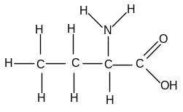
b)
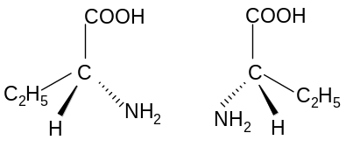

c) i) C₂H₅CH(NH₂)COOH + HCl → [C₂H₅CH(NH₃)COOH]⁺Cl⁻
ii) C₂H₅CH(NH₂)COOH + NaOH → C₂H₅CH(NH₂)COO⁻Na⁺ + H₂O

d)
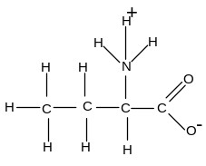
amino acids can form ionic bonds with each other in solid state
strong electrostatic attraction leads to a high melting point

e) i)
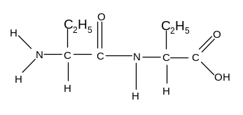
ii)
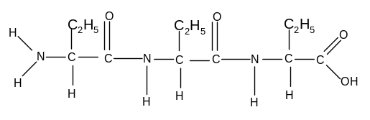
iii)
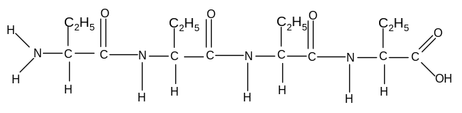

2. a) It has a helical shape.
Attraction between the H attached to the N and the N or O atoms causes the molecule to bend, forming hydrogen bonds between different peptide links.
b)
